1 run

training 1 epoch...

506.91235971450806 seconds used......

1 training finished! average train loss: 0.6466730133427404

evaluating...

Confusion matrix, without normalization

[[ 602 169 175]

[ 725 4263 216]

[ 914 384 6148]]

Normalized confusion matrix

[[0.63636364 0.17864693 0.18498943]

[0.13931591 0.81917756 0.04150653]

[0.12275047 0.05157131 0.82567822]]

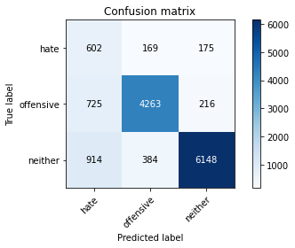

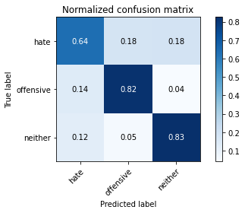

precision recall f1-score support

hate 0.27 0.64 0.38 946

offensive 0.89 0.82 0.85 5204

neither 0.94 0.83 0.88 7446

accuracy 0.81 13596

macro avg 0.70 0.76 0.70 13596

weighted avg 0.87 0.81 0.83 13596

average eval_loss: 0.49622100648634576, accuracy: 0.8100176522506619

training 2 epoch...

505.82357692718506 seconds used......

2 training finished! average train loss: 0.5038092402431129

evaluating...

Confusion matrix, without normalization

[[ 725 93 128]

[1199 3839 166]

[1357 306 5783]]

Normalized confusion matrix

[[0.76638478 0.09830867 0.13530655]

[0.23039969 0.73770177 0.03189854]

[0.1822455 0.04109589 0.77665861]]

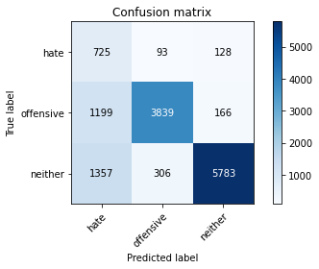

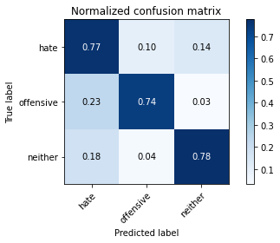

precision recall f1-score support

hate 0.22 0.77 0.34 946

offensive 0.91 0.74 0.81 5204

neither 0.95 0.78 0.86 7446

accuracy 0.76 13596

macro avg 0.69 0.76 0.67 13596

weighted avg 0.88 0.76 0.80 13596

average eval_loss: 0.5801009182215614, accuracy: 0.7610326566637247

training 3 epoch...

505.8664379119873 seconds used......

3 training finished! average train loss: 0.37679297399229517

evaluating...

Confusion matrix, without normalization

[[ 673 126 147]

[ 971 4025 208]

[1250 331 5865]]

Normalized confusion matrix

[[0.71141649 0.13319239 0.15539112]

[0.18658724 0.7734435 0.03996925]

[0.16787537 0.0444534 0.78767123]]

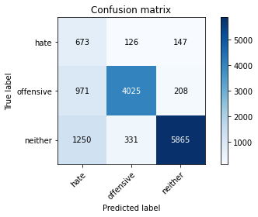

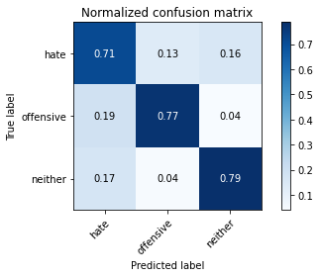

precision recall f1-score support

hate 0.23 0.71 0.35 946

offensive 0.90 0.77 0.83 5204

neither 0.94 0.79 0.86 7446

accuracy 0.78 13596

macro avg 0.69 0.76 0.68 13596

weighted avg 0.88 0.78 0.81 13596

average eval_loss: 0.5859249970163493, accuracy: 0.776919682259488

Confusion matrix, without normalization

[[1407 129 299]

[1596 3952 377]

[2479 362 7913]]

Normalized confusion matrix

[[0.76675749 0.07029973 0.16294278]

[0.26936709 0.66700422 0.06362869]

[0.23051888 0.03366189 0.73581923]]

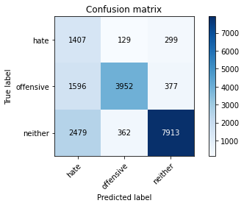

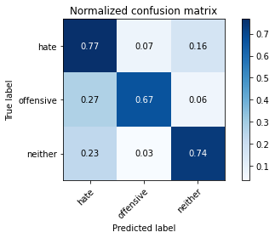

precision recall f1-score support

hate 0.26 0.77 0.38 1835

offensive 0.89 0.67 0.76 5925

neither 0.92 0.74 0.82 10754

accuracy 0.72 18514

macro avg 0.69 0.72 0.66 18514

weighted avg 0.85 0.72 0.76 18514

average eval_loss: 0.6820696417089415, accuracy: 0.7168629145511505

[18]:

0.7168629145511505

2 run

training 1 epoch...

501.0551881790161 seconds used......

1 training finished! average train loss: 0.6483227777377376

evaluating...

Confusion matrix, without normalization

[[ 660 120 166]

[ 860 4047 297]

[1051 216 6179]]

Normalized confusion matrix

[[0.69767442 0.12684989 0.17547569]

[0.16525749 0.77767102 0.05707148]

[0.14114961 0.02900886 0.82984153]]

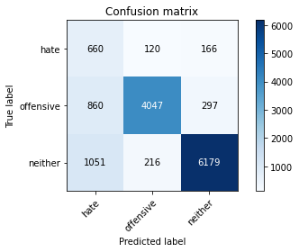

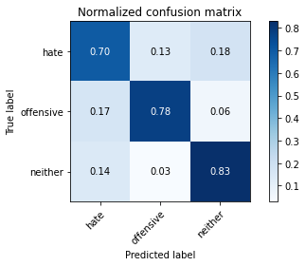

precision recall f1-score support

hate 0.26 0.70 0.38 946

offensive 0.92 0.78 0.84 5204

neither 0.93 0.83 0.88 7446

accuracy 0.80 13596

macro avg 0.70 0.77 0.70 13596

weighted avg 0.88 0.80 0.83 13596

average eval_loss: 0.492534096188405, accuracy: 0.8006766696087084

training 2 epoch...

500.9301075935364 seconds used......

2 training finished! average train loss: 0.5008329133307924

evaluating...

Confusion matrix, without normalization

[[ 704 96 146]

[1147 3840 217]

[1156 208 6082]]

Normalized confusion matrix

[[0.74418605 0.10147992 0.15433404]

[0.22040738 0.73789393 0.04169869]

[0.15525114 0.02793446 0.8168144 ]]

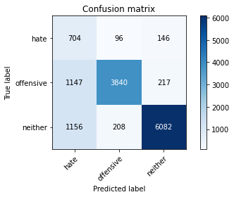

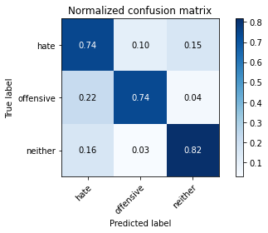

precision recall f1-score support

hate 0.23 0.74 0.36 946

offensive 0.93 0.74 0.82 5204

neither 0.94 0.82 0.88 7446

accuracy 0.78 13596

macro avg 0.70 0.77 0.68 13596

weighted avg 0.89 0.78 0.82 13596

average eval_loss: 0.5435028378249092, accuracy: 0.7815533980582524

training 3 epoch...

501.15802359580994 seconds used......

3 training finished! average train loss: 0.37721519302437895

evaluating...

Confusion matrix, without normalization

[[ 686 118 142]

[1020 3999 185]

[1292 348 5806]]

Normalized confusion matrix

[[0.72515856 0.12473573 0.15010571]

[0.19600307 0.76844735 0.03554958]

[0.17351598 0.0467365 0.77974752]]

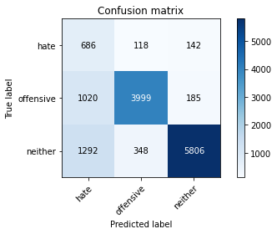

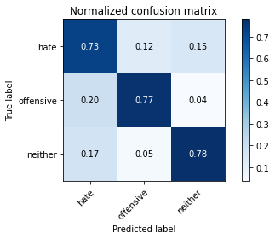

precision recall f1-score support

hate 0.23 0.73 0.35 946

offensive 0.90 0.77 0.83 5204

neither 0.95 0.78 0.86 7446

accuracy 0.77 13596

macro avg 0.69 0.76 0.68 13596

weighted avg 0.88 0.77 0.81 13596

average eval_loss: 0.6073581835090676, accuracy: 0.7716240070609003

Confusion matrix, without normalization

[[1419 116 300]

[1616 3907 402]

[2281 222 8251]]

Normalized confusion matrix

[[0.773297 0.06321526 0.16348774]

[0.27274262 0.65940928 0.0678481 ]

[0.21210712 0.02064348 0.7672494 ]]

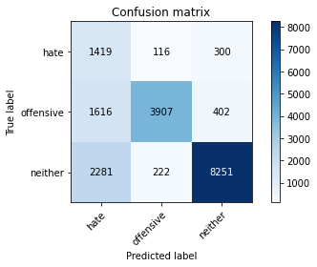

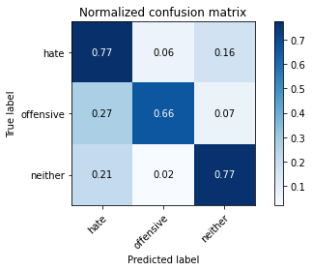

precision recall f1-score support

hate 0.27 0.77 0.40 1835

offensive 0.92 0.66 0.77 5925

neither 0.92 0.77 0.84 10754

accuracy 0.73 18514

macro avg 0.70 0.73 0.67 18514

weighted avg 0.86 0.73 0.77 18514

average eval_loss: 0.6457513023014975, accuracy: 0.7333369342119477

[22]:

0.7333369342119477

3 run

training 1 epoch...

501.0608432292938 seconds used......

1 training finished! average train loss: 0.646344861279565

evaluating...

Confusion matrix, without normalization

[[ 685 137 124]

[ 925 4085 194]

[1369 262 5815]]

Normalized confusion matrix

[[0.72410148 0.1448203 0.13107822]

[0.17774789 0.7849731 0.03727902]

[0.1838571 0.03518668 0.78095622]]

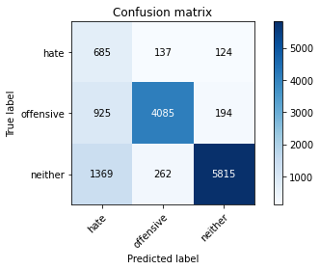

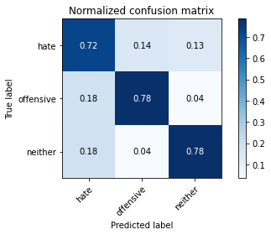

precision recall f1-score support

hate 0.23 0.72 0.35 946

offensive 0.91 0.78 0.84 5204

neither 0.95 0.78 0.86 7446

accuracy 0.78 13596

macro avg 0.70 0.76 0.68 13596

weighted avg 0.88 0.78 0.82 13596

average eval_loss: 0.5371277194251033, accuracy: 0.7785378052368344

training 2 epoch...

500.91257667541504 seconds used......

2 training finished! average train loss: 0.49973596236186274

evaluating...

Confusion matrix, without normalization

[[ 665 114 167]

[ 954 3977 273]

[ 965 247 6234]]

Normalized confusion matrix

[[0.70295983 0.1205074 0.17653277]

[0.18332052 0.76421983 0.05245965]

[0.12959979 0.03317217 0.83722804]]

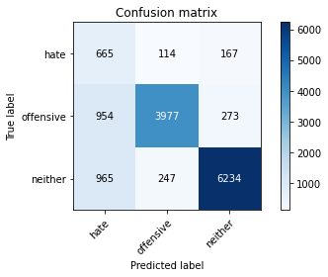

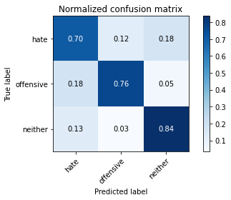

precision recall f1-score support

hate 0.26 0.70 0.38 946

offensive 0.92 0.76 0.83 5204

neither 0.93 0.84 0.88 7446

accuracy 0.80 13596

macro avg 0.70 0.77 0.70 13596

weighted avg 0.88 0.80 0.83 13596

average eval_loss: 0.4862757659133743, accuracy: 0.7999411591644602

training 3 epoch...

500.93659949302673 seconds used......

3 training finished! average train loss: 0.37156639907388717

evaluating...

Confusion matrix, without normalization

[[ 655 135 156]

[ 856 4143 205]

[1233 383 5830]]

Normalized confusion matrix

[[0.69238901 0.14270613 0.16490486]

[0.16448885 0.79611837 0.03939277]

[0.16559226 0.05143701 0.78297072]]

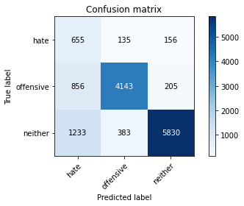

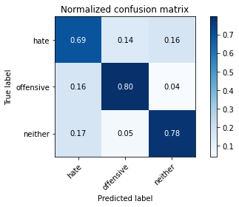

precision recall f1-score support

hate 0.24 0.69 0.36 946

offensive 0.89 0.80 0.84 5204

neither 0.94 0.78 0.86 7446

accuracy 0.78 13596

macro avg 0.69 0.76 0.68 13596

weighted avg 0.87 0.78 0.81 13596

average eval_loss: 0.5642636405632776, accuracy: 0.7817005001471021

4 run

training 1 epoch...

500.7489836215973 seconds used......

1 training finished! average train loss: 0.6500014958667083

evaluating...

Confusion matrix, without normalization

[[ 615 141 190]

[ 762 4121 321]

[ 885 231 6330]]

Normalized confusion matrix

[[0.65010571 0.14904863 0.20084567]

[0.14642583 0.79189085 0.06168332]

[0.11885576 0.03102337 0.85012087]]

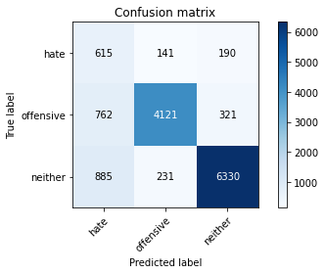

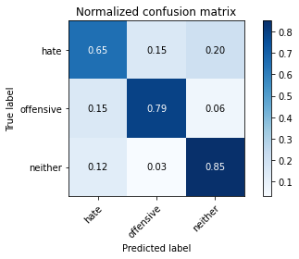

precision recall f1-score support

hate 0.27 0.65 0.38 946

offensive 0.92 0.79 0.85 5204

neither 0.93 0.85 0.89 7446

accuracy 0.81 13596

macro avg 0.70 0.76 0.71 13596

weighted avg 0.88 0.81 0.84 13596

average eval_loss: 0.4707176139578223, accuracy: 0.813915857605178

training 2 epoch...

500.9162812232971 seconds used......

2 training finished! average train loss: 0.49940863435635807

evaluating...

Confusion matrix, without normalization

[[ 712 129 105]

[ 917 4130 157]

[1437 320 5689]]

Normalized confusion matrix

[[0.75264271 0.13636364 0.11099366]

[0.17621061 0.79362029 0.0301691 ]

[0.19298952 0.04297609 0.76403438]]

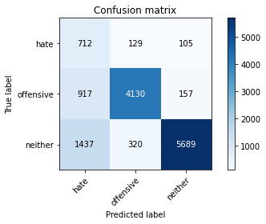

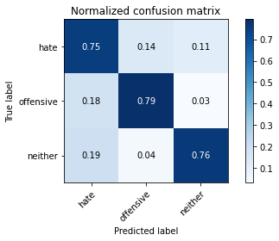

precision recall f1-score support

hate 0.23 0.75 0.35 946

offensive 0.90 0.79 0.84 5204

neither 0.96 0.76 0.85 7446

accuracy 0.77 13596

macro avg 0.70 0.77 0.68 13596

weighted avg 0.88 0.77 0.81 13596

average eval_loss: 0.5683624726227101, accuracy: 0.7745660488378935

training 3 epoch...

500.728045463562 seconds used......

3 training finished! average train loss: 0.37370891493761355

evaluating...

Confusion matrix, without normalization

[[ 634 181 131]

[ 736 4275 193]

[1090 497 5859]]

Normalized confusion matrix

[[0.67019027 0.19133192 0.1384778 ]

[0.14142967 0.82148347 0.03708686]

[0.14638732 0.06674725 0.78686543]]

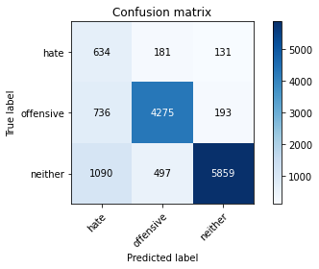

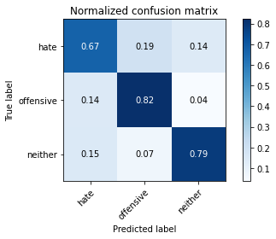

precision recall f1-score support

hate 0.26 0.67 0.37 946

offensive 0.86 0.82 0.84 5204

neither 0.95 0.79 0.86 7446

accuracy 0.79 13596

macro avg 0.69 0.76 0.69 13596

weighted avg 0.87 0.79 0.82 13596

average eval_loss: 0.5332923079676488, accuracy: 0.7919976463665784

Confusion matrix, without normalization

[[1415 152 268]

[1333 4267 325]

[2736 353 7665]]

Normalized confusion matrix

[[0.77111717 0.08283379 0.14604905]

[0.2249789 0.72016878 0.05485232]

[0.25441696 0.032825 0.71275804]]

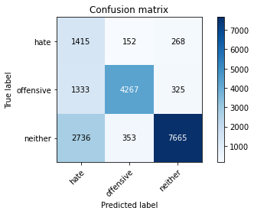

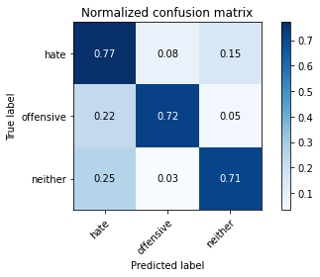

precision recall f1-score support

hate 0.26 0.77 0.39 1835

offensive 0.89 0.72 0.80 5925

neither 0.93 0.71 0.81 10754

accuracy 0.72 18514

macro avg 0.69 0.73 0.66 18514

weighted avg 0.85 0.72 0.76 18514

average eval_loss: 0.6823642704128962, accuracy: 0.7209139029923302

[26]:

0.7209139029923302

5 run

training 1 epoch...

500.53051495552063 seconds used......

1 training finished! average train loss: 0.6509153349471665

evaluating...

Confusion matrix, without normalization

[[ 617 193 136]

[ 645 4397 162]

[1059 540 5847]]

Normalized confusion matrix

[[0.65221987 0.20401691 0.14376321]

[0.12394312 0.84492698 0.0311299 ]

[0.14222401 0.07252216 0.78525383]]

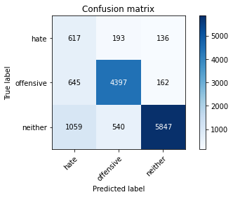

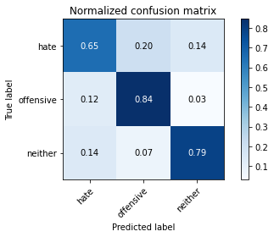

precision recall f1-score support

hate 0.27 0.65 0.38 946

offensive 0.86 0.84 0.85 5204

neither 0.95 0.79 0.86 7446

accuracy 0.80 13596

macro avg 0.69 0.76 0.70 13596

weighted avg 0.87 0.80 0.82 13596

average eval_loss: 0.5026713776456959, accuracy: 0.7988378934980876

training 2 epoch...

500.0854380130768 seconds used......

2 training finished! average train loss: 0.503256799451013

evaluating...

Confusion matrix, without normalization

[[ 698 115 133]

[ 945 4016 243]

[1256 216 5974]]

Normalized confusion matrix

[[0.73784355 0.12156448 0.14059197]

[0.18159108 0.77171407 0.04669485]

[0.16868117 0.02900886 0.80230997]]

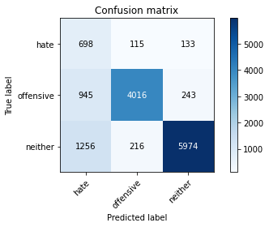

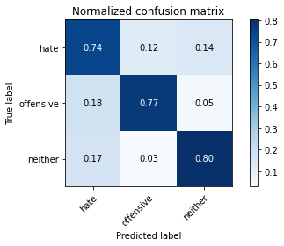

precision recall f1-score support

hate 0.24 0.74 0.36 946

offensive 0.92 0.77 0.84 5204

neither 0.94 0.80 0.87 7446

accuracy 0.79 13596

macro avg 0.70 0.77 0.69 13596

weighted avg 0.89 0.79 0.82 13596

average eval_loss: 0.5280063026529901, accuracy: 0.7861135628125919

training 3 epoch...

500.2000799179077 seconds used......

3 training finished! average train loss: 0.3760247189542333

evaluating...

Confusion matrix, without normalization

[[ 650 127 169]

[ 941 4059 204]

[ 974 400 6072]]

Normalized confusion matrix

[[0.68710359 0.13424947 0.17864693]

[0.18082244 0.77997694 0.03920061]

[0.13080849 0.05372012 0.81547139]]

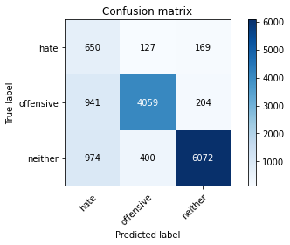

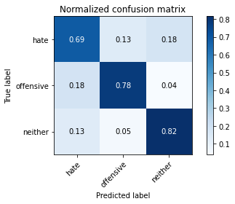

precision recall f1-score support

hate 0.25 0.69 0.37 946

offensive 0.89 0.78 0.83 5204

neither 0.94 0.82 0.87 7446

accuracy 0.79 13596

macro avg 0.69 0.76 0.69 13596

weighted avg 0.87 0.79 0.82 13596

average eval_loss: 0.5661976966897354, accuracy: 0.7929538099441013

Confusion matrix, without normalization

[[1362 150 323]

[1351 4154 420]

[2282 247 8225]]

Normalized confusion matrix

[[0.74223433 0.08174387 0.1760218 ]

[0.22801688 0.70109705 0.07088608]

[0.21220011 0.0229682 0.76483169]]

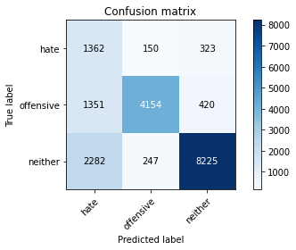

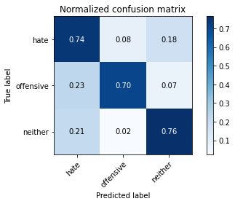

precision recall f1-score support

hate 0.27 0.74 0.40 1835

offensive 0.91 0.70 0.79 5925

neither 0.92 0.76 0.83 10754

accuracy 0.74 18514

macro avg 0.70 0.74 0.68 18514

weighted avg 0.85 0.74 0.78 18514

average eval_loss: 0.6199818131057284, accuracy: 0.7421950956033272

[18]:

0.7421950956033272